**Spring**

16

**UCLA MAE154B**

08

**Fall**

CAP Aerospace

*Pedram Madanchian*

*Chris Madariaga*

*Andrew Tenorio*

Table of Contents

List of Figures 3

List of Tables 4

1) Introduction 5

1.1) Project Description 5

1.2) Gantt Chart 6

1.3) Selection of Aircraft 6

2) Aerodynamic Loads 9

2.1) XFOIL Analysis 9

2.2) V-n Diagrams 13

2.2.1) Maneuverable Envelope 13

2.2.2) Gust Loading 17

2.2.3) Allowable Envelope 20

3) Airframe Loads 22

3.1) Load Distributions 23

3.1.1) Lift Distribution 23

3.1.2) Drag Distribution 25

3.1.3) Total Load Distribution on Wing 27

3.2) Wing Structure 30

3.2.1) Geometry (Cantilever beam model) 30

3.2.2) Centroid 31

3.2.3) Area Moment of Inertia 34

3.3) Structural Loads 34

3.3.1) Bending Moments 34

3.3.2) Stress 34

3.3.3) Shear 34

3.3.4) Wing Tip Deflection 34

4) Conclusion and upcoming work 34

5) References 34

6) Appendix 34

## List of Figures

Figure 1: Gantt Chart 6

Figure 2: Cessna Cardinal 177B 8

Figure 3: 2-D Lift Curve for NACA 2415 (Sea Level) 11

Figure 4: 2-D Lift Curve for NACA 2415 (4,450 m) 12

Figure 5: Maneuver Envelope (Sea Level) 16

Figure 6: Maneuver Envelope (Service Ceiling) 17

Figure 7: Gust Load Diagram (Sea Level) 20

Figure 8: Gust Load Diagram (Altitude) 20

Figure 9: Allowable Envelope (Sea Level) 22

Figure 10: Allowable Envelope (Altitude) 23

Figure 11: Lift Distribution (Sea Level) 25

Figure 12: Lift Distribution (Altitude) 25

Figure 13: Drag Distribution (Sea Level) 27

Figure 14: Drag Distribution (Altitude) 27

Figure 16: Wing Load Distribution (Sea Level) 29

Figure 17: Wing Load Distribution (Altitude) 30

Figure 18: Approximate Wing Geometry 32

Figure 19: Point Numbering Convention 33

Figure 20: Approximate Wing Geometry w/ Centroid Locations 34

## List of Tables

Table 1: Initial Sizing and Specifications 8

Table 2: Calculated Mach and Reynolds numbers (Sea Level and Altitude) 10

Table 3: Summary of 2-D Lift Characteristics for NACA 2415 12

Table 4: Summary of 3-D Lift Characteristics for NACA 2415 12

Table 5: Summary of Load Limits (FAR 23) 13

Table 6: Summary of Aircraft Velocities Considered for Flight Envelope 14

Table 7: Summary of Maneuver Critical Points 17

Table 8: Gust Velocities @ Cruise and Dive (FAR 23) 17

Table 9: Critical Gust Points 20

Table 10: Allowable Envelope Critical Points 21

Figure 15: Coordinate Axes for Transformation 27

Table 11: Structural Component Sizing 30

Table 12: Centroid Coordinates 33

# 1) Introduction

This preliminary design report (PDR) contains the progress of work completed for the UCLA MAE 154B course, which will ultimately lead to the design and analysis of an aircraft wing. Federal Aviation Regulations are considered and used as constraints in the ongoing process of the design. Tools such as XFOIL were used in determining aerodynamic characteristics of the airfoil selection, which were essential in constructing V-n diagrams. This project also relies heavily on the implementation of code written in MATLAB to determine the analysis of loads and sizing of the aircraft under static conditions. Further use of such tools will be used in following weeks, as the design process and analysis of the wing continues. More details on the project and design are outlined in the following sections.

## 1.1) Project Description

The final project will be the complete design and analysis of a wing, which is to be used for a utility aircraft. The design of this structure must strictly adhere to the Federal Aviation Regulations Part 23 (FAR 23). For simplicity in calculations, the wing will be straight and have no taper. The goal is to design the wing such that it is structurally sound, while maintaining the lowest possible weight. Different software will be utilized throughout this project in order to achieve this goal, such as XFOIL, MATLAB, SolidWorks, and others. An optimization process will also be used in order to ensure minimal weight for the design of the wing. The following Gantt chart shows the progress of the design up to this point.

## 1.2) Gantt Chart

The Gantt chart below details the design progress thus far and shows the division of responsibilities for each task and is labeled Figure 1.

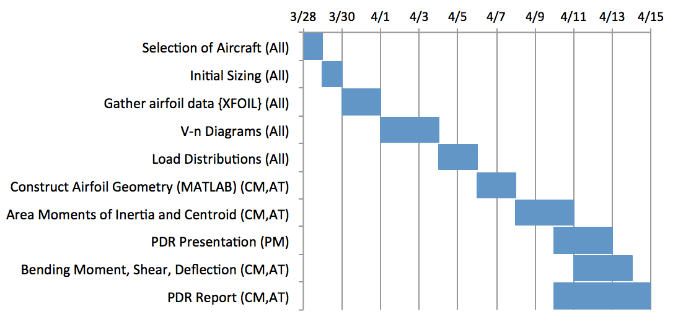

Figure : Gantt Chart

As seen in the figure above, the description of each task is labeled along with the date and duration. The students responsible for each particular task are also shown on the chart, denoted by their initials. First, a survey of aircraft was conducted such that the requirements outlined in the project description were met, and the final selection is detailed below.

## 1.3) Selection of Aircraft

In order to begin working on the project, a similar aircraft study was used to initially size the aircraft. As stated above, a utility aircraft with a straight wing and zero taper was desired. The result of this survey led to the selection of the Cessna Cardinal 177B, and is shown in Figure 2 below.

**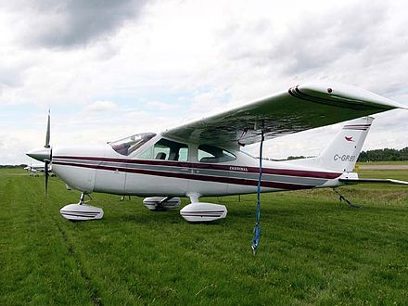**

Figure : Cessna Cardinal 177B

The Cessna Cardinal 177B satisfies the requirements outlined in the project description and employs a simplistic design. The wing design is assumed to be straight and contain zero taper, which makes the analysis simpler. The NACA 2415 airfoil was not used for the entire wing, but this assumption was made. The specifications of the aircraft are shown in Table 1 below.

|  |  |
| --- | --- |
| Airfoil | NACA 2415 |
| Wingspan | 10.82 [m] |
| Wing Area | 16.2 [m2] |
| Aspect Ratio | 7.23 |
| Chord Length\* | 1.5 [m] |
| Max Takeoff Mass | 1,100 [kg] |
| Max Speed | 250 [km/h] |
| Cruise Speed | 230 [km/h] |
| Service Ceiling | 4,450 [m] |

Table : Initial Sizing and Specifications

The specifications shown in Table 1 above were taken from the Cessna Cardinal 177B, except for the chord length which was denoted with a \*. With the wingspan, wing area and wing shape shown, the chord length was calculated using Equation 1 below.

*(Equation 1)*

where c is defined as the chord length (m), S is the wing area (m2), b is the wingspan (m), and the equation is valid for rectangular wings. In addition to the initial sizing purposes, these specifications were also used to gather aerodynamic data, as shown in the following section.

# 2) Aerodynamic Loads

With the information gathered from the aircraft survey, a NACA 2415 airfoil was chosen for the wing. Several aerodynamic parameters for the aircraft were determined by analyzing the NACA 2415 airfoil using XFOIL. This analysis and the regulations outlined in the FAR 23 were essential in order to construct the flight envelope for the aircraft (V-n diagrams). The details of these calculations are shown in the following sections, beginning with the XFOIL analysis.

## 2.1) XFOIL Analysis

In order to determine the allowable flight envelope for the aircraft, aerodynamic parameters such as the lift characteristics were needed. XFOIL is useful software that can generate the above-mentioned parameters necessary to create V-n diagrams. A built in database for the NACA series airfoils was used in XFOIL, and the NACA 2415 was selected. Next, the Mach number and Reynolds number were determined at both sea level and at the service ceiling of 4,450 m, using Equation 2 and Equation 3 respectively.

*(Equation 2)*

*(Equation 3)*

where M is the Mach number, v is the velocity (m/s), a is the speed of sound (m/s), Re is the Reynolds number, ρ is the density (kg/m3), and μ is the dynamic viscosity (Pa-s). The results of these calculations for sea level and altitude are shown in Table 2 below.

|  |  |  |
| --- | --- | --- |
|  | Sea Level | Altitude (4,450 m) |
| M | 0.1876 | 0.1979 |
| Re | 6.54E+06 | 4.53E+06 |

Table : Calculated Mach and Reynolds numbers (Sea Level and Altitude)

With these flight parameters input into XFOIL, the airfoil was analyzed for a range of angle of attacks in order to construct the 2-D lift curve slope for sea level and altitude. The results of the XFOIL analysis are shown in Figure 3 and Figure 4 for sea level and at altitude respectively.

Macintosh HD:Users:ChrisMadariaga:Desktop:Cl_sealevel.pdf

Figure : 2-D Lift Curve for NACA 2415 (Sea Level)

Macintosh HD:Users:ChrisMadariaga:Desktop:cl_altitude.pdf

Figure : 2-D Lift Curve for NACA 2415 (4,450 m)

By examining Figure 3, the value of Cl,MAX (maximum 2-D lift coefficient) at sea level is shown to be 1.835, while Cl,MIN (minimum 2-D lift coefficient) at sea level is shown to be -1.6419. The lift curve slope was also determined by taking the slope of the linear region (approximately -7° < α < 10°) and converted into rad-1. The value at sea level for Cl,α was found to be 6.544 rad-1. Similarly, these values were found in Figure 4 for the NACA 2415 airfoil at altitude. The value of Cl,MAX at altitude is shown to be 1.7735 (3.41% difference from sea level), while Cl,MIN at altitude is shown to be -1.5503 (5.74% difference from sea level). The lift curve slope was determined in a similar manner as described above and was found to be 6.543 rad-1 (0.015% difference). These results are summarized in Table 3 below.

|  |  |  |  |
| --- | --- | --- | --- |
|  | Sea Level | Altitude | |% Difference| |
| Cl,MAX | 1.835 | 1.7735 | 3.41 |
| Cl,MIN | -1.6419 | -1.5503 | 5.74 |
| Cl,α [rad-1] | 6.543 | 6.544 | 0.015 |

Table : Summary of 2-D Lift Characteristics for NACA 2415

With the 2-D lift characteristics known, the following conversions, shown in Equation 4 and Equation 5, were used to transform the 2-D parameters into 3-D parameters.

*(Equation 4)*

*(Equation 5)*

where CL,α is the 3-D lift curve slope, AR is the aspect ratio, e is the Oswald efficiency factor (assumed to be 0.79), and CL is the 3-D lift coefficient. The results of these conversions are shown in Table 4.

|  |  |  |  |
| --- | --- | --- | --- |
|  | Sea Level | Altitude | |% Difference| |
| CL,MAX | 1.35 | 1.30 | 3.77 |
| CL,MIN | -1.20 | -1.14 | 5.13 |
| CL,α [rad-1] | 4.78 | 4.79 | 0.21 |

Table : Summary of 3-D Lift Characteristics for NACA 2415

With the 3-D parameters known from Table 4, V-n diagrams were created in order to determine the allowable flight envelope at both sea level and altitude.

## 2.2) V-n Diagrams

V-n diagrams were constructed in order to determine the capabilities of the aircraft at sea level and altitude (4,450 m). The diagrams show the limit of the load factor that can be sustained at different airspeeds, and are comprised of two different scenarios in flight, including the maneuverable envelope and gust load considerations. After comparing these two plots and determining which produced a greater load factor (in magnitude), a diagram for the allowable envelope was created. First, the details of the maneuverable envelope are shown below.

### 2.2.1) Maneuverable Envelope

The maneuverable envelope is determined by the positive load factor stall curve, negative load factor stall curve and the FAR 23 regulations, which dictates the positive and negative limit maneuvering loads and the negative limit at dive. The values of these load factors are summarized in Table 5 below.

|  |  |  |  |
| --- | --- | --- | --- |
|  | Positive Limit Maneuvering Load [n1] | Negative Limit Maneuvering Load [n2] | Negative Limit at Dive Speed  [n3] |
| n | 4.4 | -1.76 | -1 |

Table : Summary of Load Limits (FAR 23)

With the load limits shown above and the aerodynamic parameters calculated from XFOIL, the maneuverable envelope was constructed for sea level and at the service ceiling. The positive portion of the envelope is first governed by positive stall, as shown in Equation 6.

*(Equation 6)*

where ρ is the density of air [kg/m3], V is the velocity [m/s], S is the wing area [m2], CL,MAX is the maximum 3-D lift coefficient and W is the weight [N]. This curve was followed until the positive load limit of 4.4, where the load factor remains constant until the velocity reaches VDive, defined in Equation 7 below.

*(Equation 7)*

where VCruise is simply the cruise velocity, a parameter of the Cessna 177B Cardinal. The dive velocity then remains constant as the load factor decreases to the negative dive limit of -1, governed by the FAR 23. As the velocity decreases from VDive to VCruise, the load factor also decreases linearly, until the negative maneuver limit of -1.76. The load factor will remain constant as velocity decreases at this negative limit until it is intersected by the negative stall curve, shown by Equation 8.

*(Equation 8)*

where CL,MIN is the minimum 3-D lift coefficient and the other parameters have been previously defined. Following the nneg curve as velocity decreases to 0 completes the maneuver envelope. A summary of the velocities considered for the flight envelope is shown in Table 6.

|  |  |  |  |  |
| --- | --- | --- | --- | --- |
|  | Vs,pos [m/s] | Vs,neg  [m/s] | VCruise [km/h] | VDive [km/h] |
| Sea Level | 28.38 | 30.01 | 230 | 345 |
| Altitude | 36.21 | 38.68 | 230 | 345 |

Table : Summary of Aircraft Velocities Considered for Flight Envelope

Vs,pos is the stall velocity corresponding to a load factor of 1 and Vs,neg is the stall velocity corresponding a load factor of -1. These values were found using Equation 9 and Equation 10.

*(Equation 9)*

*(Equation 10)*

where the inputs for Vs,pos and Vs,neg were previously defined. Figure 5 and Figure 6 show the total maneuver envelopes for sea level and at altitude respectively.

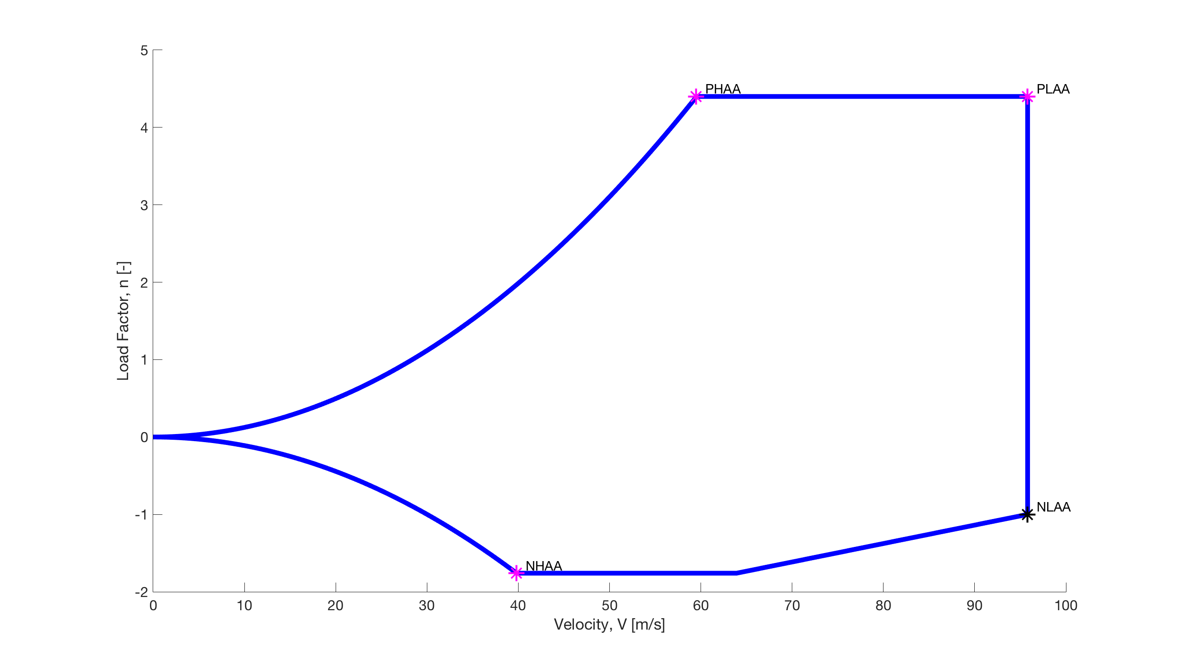

Figure : Maneuver Envelope (Sea Level)

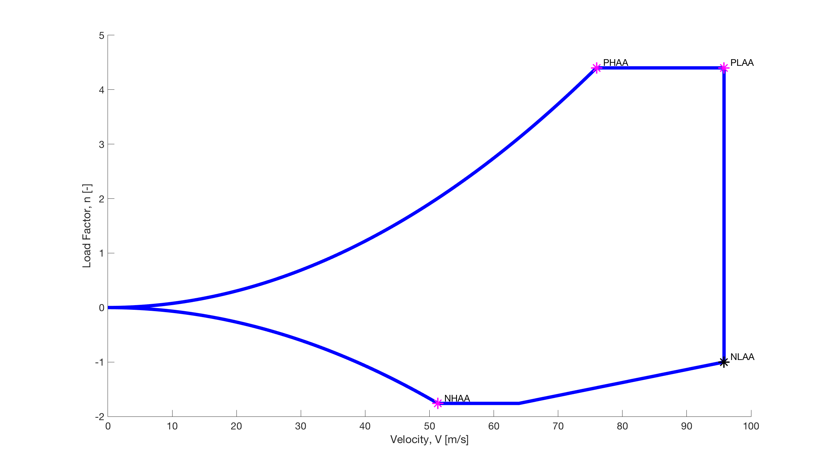

Figure : Maneuver Envelope (Service Ceiling)

As Figure 5 and Figure 6 are examined, the diagrams follow the outline described above, with the addition of several critical points. These critical points are the peak load conditions to be considered when ensuring the aircraft is structurally sound. The positive high angle of attack (PHAA) is the point in which the aircraft first reaches the positive load factor limit of 4.4, while flying at CL,MAX. The positive low angle of attack (PLAA) is the point when the aircraft maintains a load factor of 4.4 and reaches a velocity of VDive. With the velocity remaining constant at VDive, the load factor decreases until the negative dive limit of -1, which is denoted as the negative low angle of attack (NLAA). Finally, the negative high angle of attack (NHAA) is the point in which the negative stall curve first reaches the negative maneuverable limit of -1.76. Table 7 summarizes the pertinent information at each of these critical points, with the exception of NLAA as the minimum load factor at the dive velocity is due to gust (shown in the following section).

|  |  |  |  |
| --- | --- | --- | --- |
|  | PHAA  Sea|Alt | PLAA  Sea|Alt | NHAA  Sea|Alt |
| V [m/s] | 59.5|76 | 95.8|95.8 | 39.8|51.3 |
| n | 4.4|4.4 | 4.4|4.4 | -1.76|-1.76 |
| α [°] | 19|18.5 | 4.03|7.56 | -19|-17.5 |

Table : Summary of Maneuver Critical Points

If gusts were neglected, this would conclude the flight envelope. In accordance with the FAR 23, however, a diagram of the gust loads must also be considered.

### 2.2.2) Gust Loading

As the aircraft is in flight, it will surely encounter gusts. These gust loads are assumed to be vertical and symmetric, and will increase the loads placed on the aircraft structure. According to the FAR 23, the following assumptions are to be made for flight between sea level and 20,000 ft (6096 m), as seen in Table 8.

|  |  |  |
| --- | --- | --- |
|  | Cruise | Dive |
| Ue | 50 ft/s  (15.24 m/s) | 25 ft/s  (7.62 m/s) |

Table : Gust Velocities @ Cruise and Dive (FAR 23)

Where Ue is the gust velocity and the values are given for both cruise and dive flight conditions. The load factor for gusts at cruise and dive, from the FAR 23, is found using Equation 11 below.

*(Equation 11)*

where Kg is the gust alleviation factor, CL,α is the 3-D lift curve slope (in rad-1), Ue is the gust velocity (in ft/s), V is the velocity (in knots) and W/S is the wing loading (in lbf/ft2). Equation 12 and Equation 13 define the gust alleviation factor.

*(Equation 12)*

*(Equation 13)*

where μ is a non dimensional term defined by the wing loading (in lbf/ft2), air density (slugs/ft3), chord length (in ft) and the gravitational acceleration constant, g (in ft/s2). To begin the gust load diagram, two straight lines were created by connecting a point from a load factor of 1 to both nc and nd, the gust load factors for cruise and dive determined by Equation 11 above. A third line connecting nc to nd was then created in order to complete the top portion of the gust load diagrams. As mentioned above, the gust loads were assumed to be vertical and symmetric, so reflecting the plot about n=1 completed the gust load diagram.

There are four critical points for each gust load diagram, which include the maximum load factor for flight at cruise, nc, the maximum load factor for flight during dive, nd, and their respective load factors when reflecting the diagram about n=1. Table 9 shows the parameters at these critical points, while Figure 7 and Figure 8 show the completed gust load diagrams for sea level and altitude.

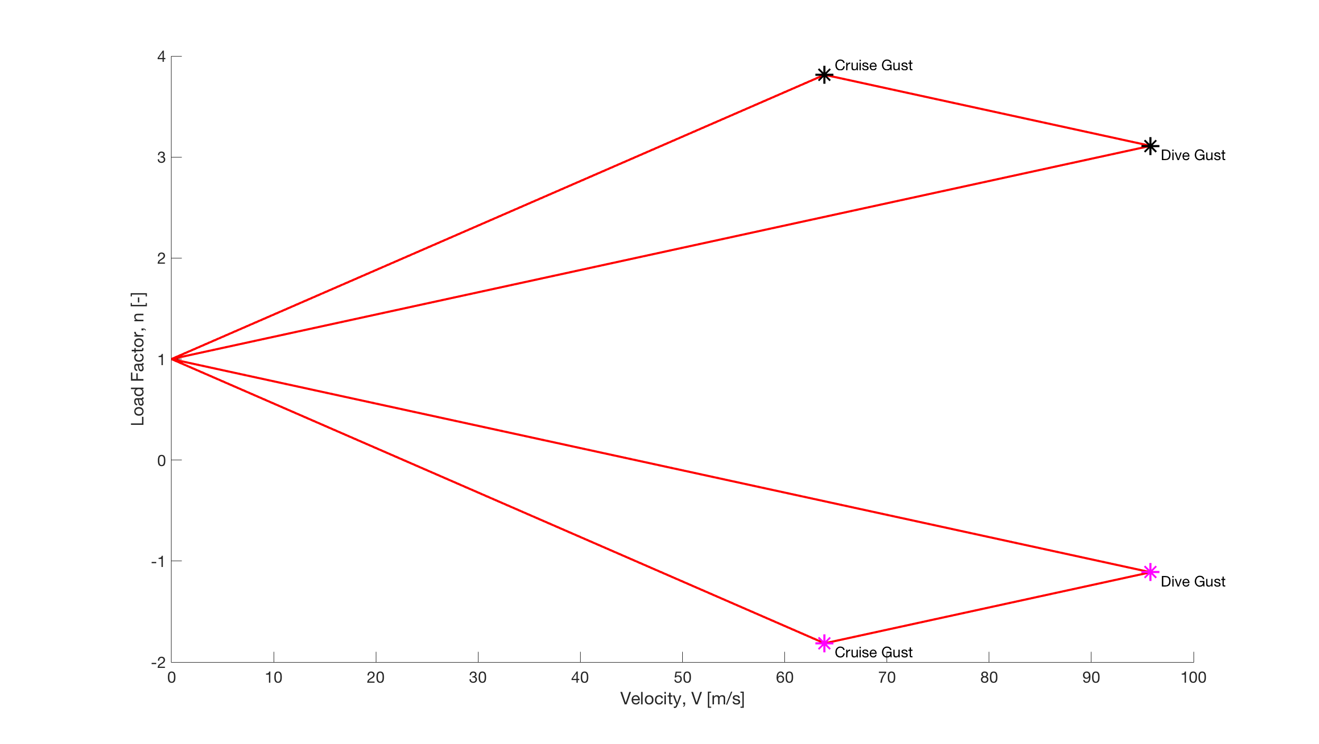

Figure : Gust Load Diagram (Sea Level)

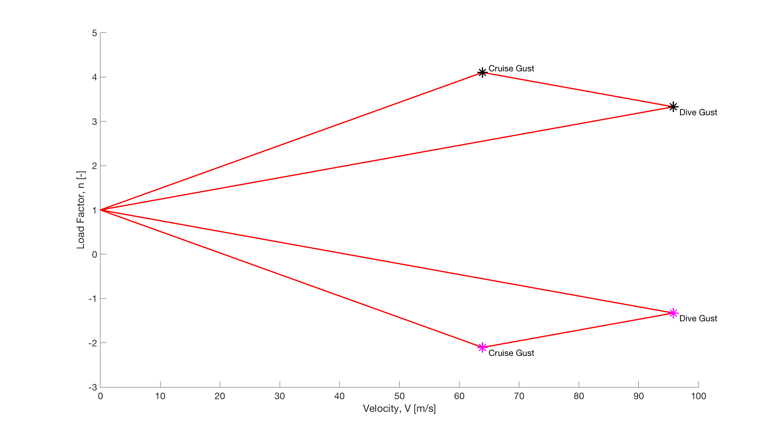

Figure : Gust Load Diagram (Altitude)

|  |  |  |  |  |
| --- | --- | --- | --- | --- |
|  | Cruise Gust (Pos)  Sea|Alt | Dive Gust (Pos)  Sea|Alt | Cruise Gust (Neg)  Sea|Alt | Dive Gust (Neg)  Sea|Alt |
| V [m/s] | - | - | 63.9 | 95.8 |
| n | - | - | -1.81|-2.10 | -1.11|-1.33 |
| α [°] | - | - | -7.98|-12.67 | -3.77|-5.14 |

Table : Critical Gust Points

As noted above, the load factor due to gust during dive for the bottom portion of the gust diagram exceeds (in magnitude) the load factor at the PLAA, so it must be considered. This is not the case for the upper portion, however, and those gust loads were neglected. This will be evident when examining the completed allowable envelope in the following section.

### 2.2.3) Allowable Envelope

The total allowable envelope is the combination of both the maneuvering envelope and the gust load limits. The gust loads before the positive high angle of attack and negative high angle of attack were neglected when constructing the allowable envelope, as the load factor in these regions is dictated by the stall curve. Another assumption made was that the positive and negative stall curves were only considered when the load factor reached a value of 1 and -1 respectively. By taking into account the extreme load cases during maneuver and gust, the aircraft design will be structurally sound. The critical points and relevant parameters for the allowable envelope are shown in Table 10. The NLAA point from the maneuver envelope, as well as the upper portion of the gust load diagrams were neglected, for the reasons explained in the preceding sections.

|  |  |  |  |  |  |
| --- | --- | --- | --- | --- | --- |
|  | Cruise Gust  (Neg)  Sea|Alt | Dive Gust (Neg)  Sea|Alt | PHAA  Sea|Alt | PLAA  Sea|Alt | NHAA  Sea|Alt |
| V [m/s] | 63.9 | 95.8 | 59.5|76 | 95.8|95.8 | 39.8|51.3 |
| n | -1.81|-2.10 | -1.11|-1.33 | 4.4|4.4 | 4.4|4.4 | -1.76|-1.76 |
| α [°] | -7.98|-12.67 | -3.77|-5.14 | 19|18.5 | 4.03|7.56 | -19|-17.5 |

Table : Allowable Envelope Critical Points

The values for NLAA are neglected as the gust load exceeds that of the maneuver load during dive. The allowable envelope for sea level and altitude are shown in Figure 9 and Figure 10.

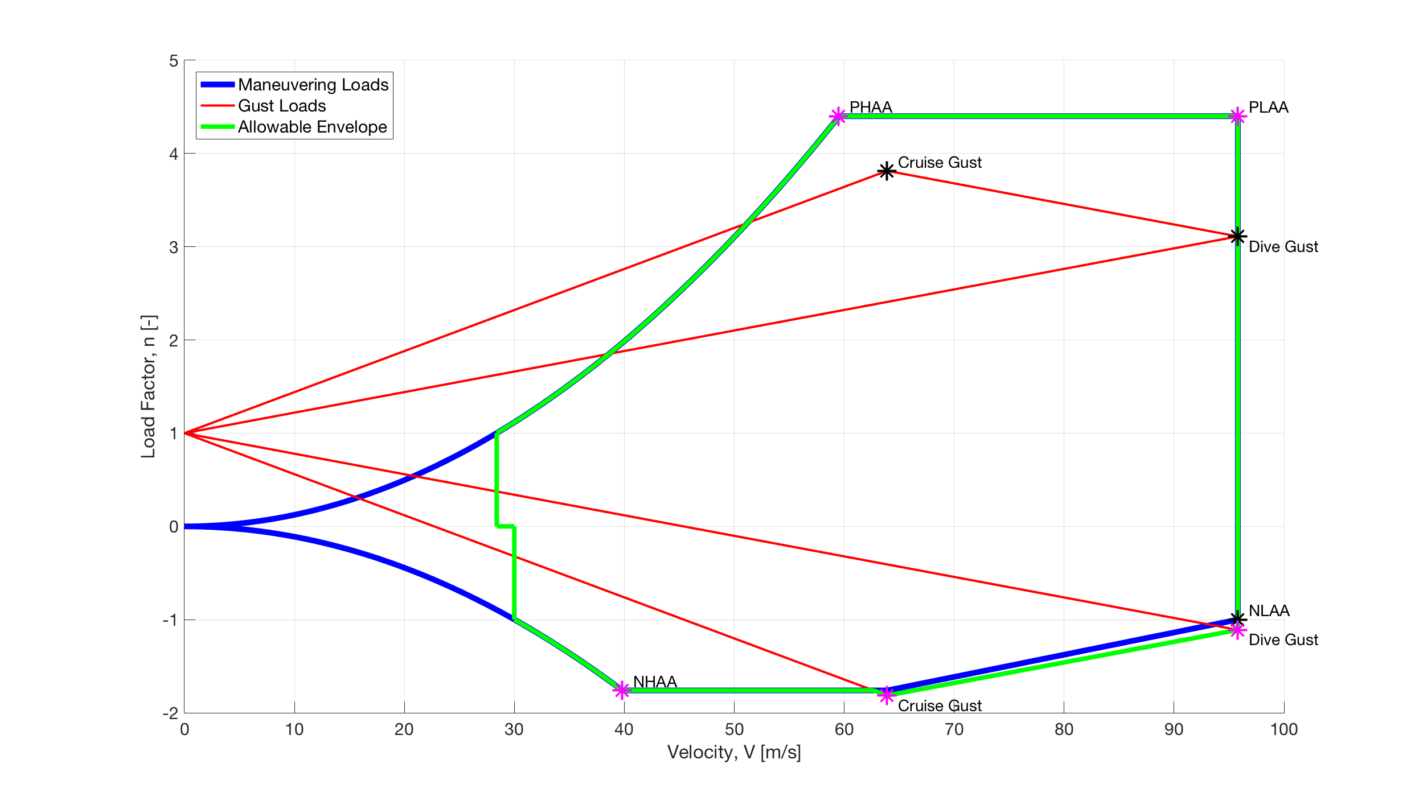

Figure : Allowable Envelope (Sea Level)

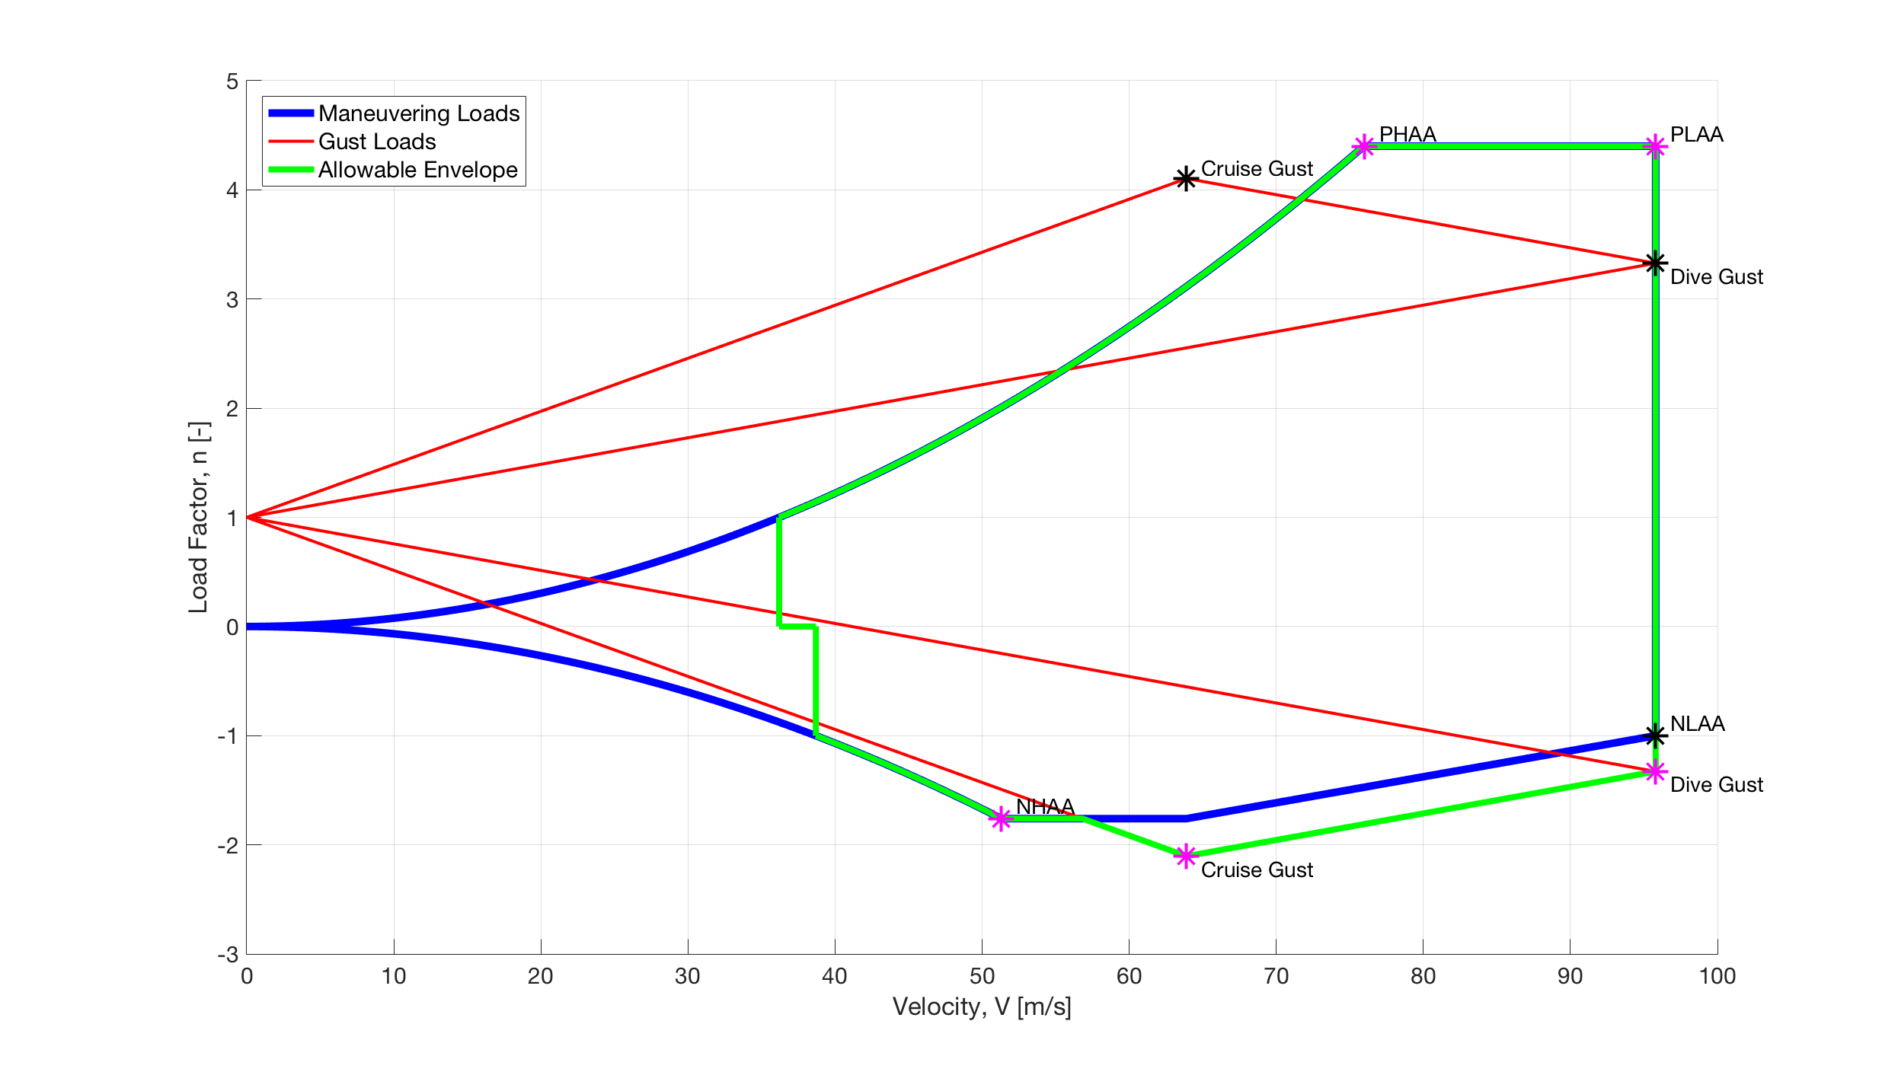

Figure : Allowable Envelope (Altitude)

For both sea level and altitude, the critical points are at PHAA, PLAA and NHAA, as well as the peak cruise and dive gust load factors. These critical points were considered when determining the lift and drag distributions, as well as the total load distribution on the wing.

# 3) Airframe Loads

The loads analyzed for the aircraft were the lift distribution and drag distribution. These loads were broken down into components that were normal to the wing and parallel to the wing, taking into account the angle of attack. The points of interest were the five critical points, mentioned above, and were plotted on the same graph to show which of the critical points had the largest loads.

## 3.1) Load Distributions

The load distributions at each critical point were analyzed for flight both at sea level and at altitude. When constructing the load distribution plots, assumptions were made in order to obtain a general shape for the lift and drag distributions. For lift, an average of a rectangular and elliptical distribution was used in order to obtain the final lift distribution. For drag, only a rectangular distribution was assumed, but with an additional 10% of drag over the last 20% of the span to account for vortex shedding. The wing load distribution is a combination of the lift and drag distributions, due to flight at a non-zero angle of attack. More details are shown below, beginning with the lift distribution.

### 3.1.1) Lift Distribution

The lift distribution, as outlined above, was assumed to be the average of a rectangular and elliptical lift distribution. Equations 14-16 below show how the total lift distribution was found.

*(Equation 14)*

*(Equation 15)*

*(Equation 16)*

where L is the total lift on the wing, b is the span, and z is the distance along the span from the root of the wing.

Figure 11 and Figure 12 show the lift distribution for each critical point at sea level and altitude, respectively.

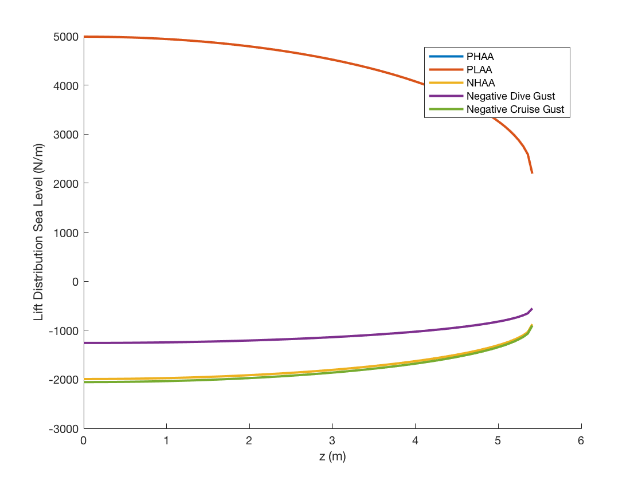

Figure : Lift Distribution (Sea Level)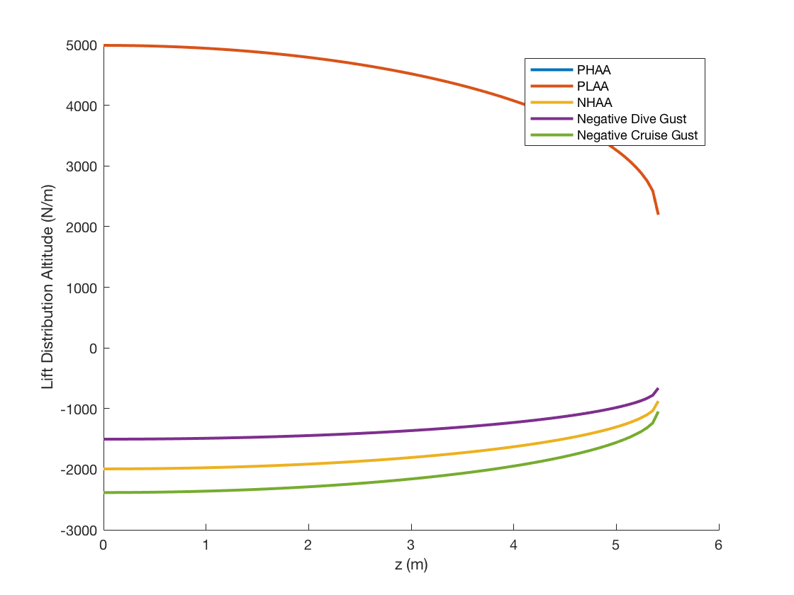

Figure : Lift Distribution (Altitude)

Note that these plots produced are for the half span of the wing, but will be symmetric about the y-axis. Due to the assumption of the elliptical distribution, the load distribution at the root is a maximum. It appears that the PHAA and PLAA critical points reach the greatest peak load distribution magnitude, near 5,000 N/m for both sea level and altitude. The PHAA and PLAA plots coincide, as the load factor is the same for both cases. For the other critical points, the values of the lift distribution are negative (though still greatest in magnitude at the root), but increasing along the span. Among the negative list distributions, the cruise gust critical point obtains the largest load distribution (magnitude) around 2,400 N/m for altitude and 2000 N/m. The next load distribution that was analyzed was the drag distribution.

### 3.1.2) Drag Distribution

The drag distribution was assumed to be rectangular across the span, with a 10% increase over the last 20% of the span, due to vortex shedding near the tips. Equation 17 and Equation 18 describe the drag distribution.

*(Equation 17)*

*(Equation 18)*

where D is the total drag on the wing (excluding the vortex shedding) and b is the span of the wing. Similarly to the plots of lift distribution, the drag distributions are shown only for the positive half span, but are symmetric about the y-axis. Figure 13 and Figure 14 show the drag distributions at sea level and at altitude, respectively.

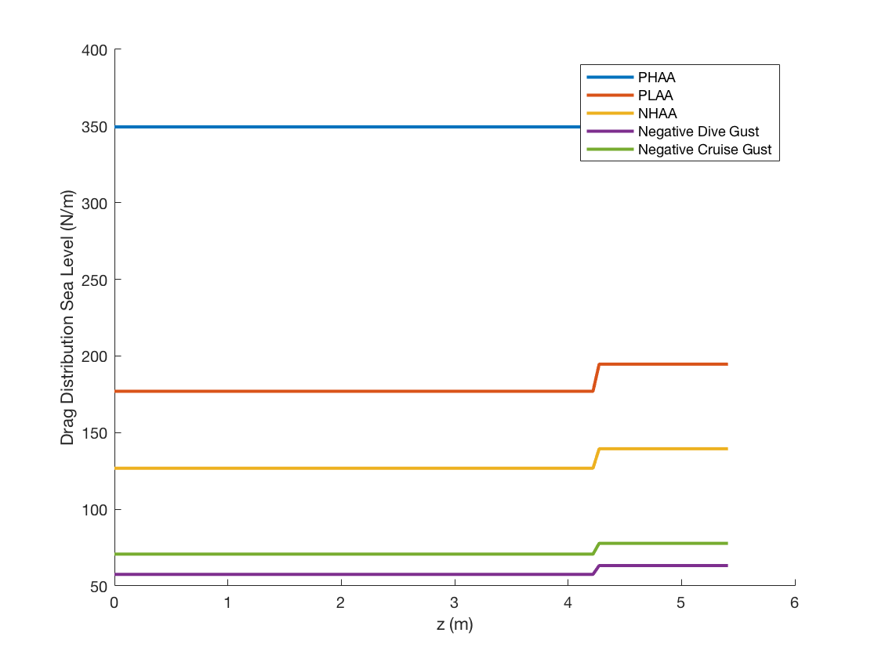

Figure : Drag Distribution (Sea Level)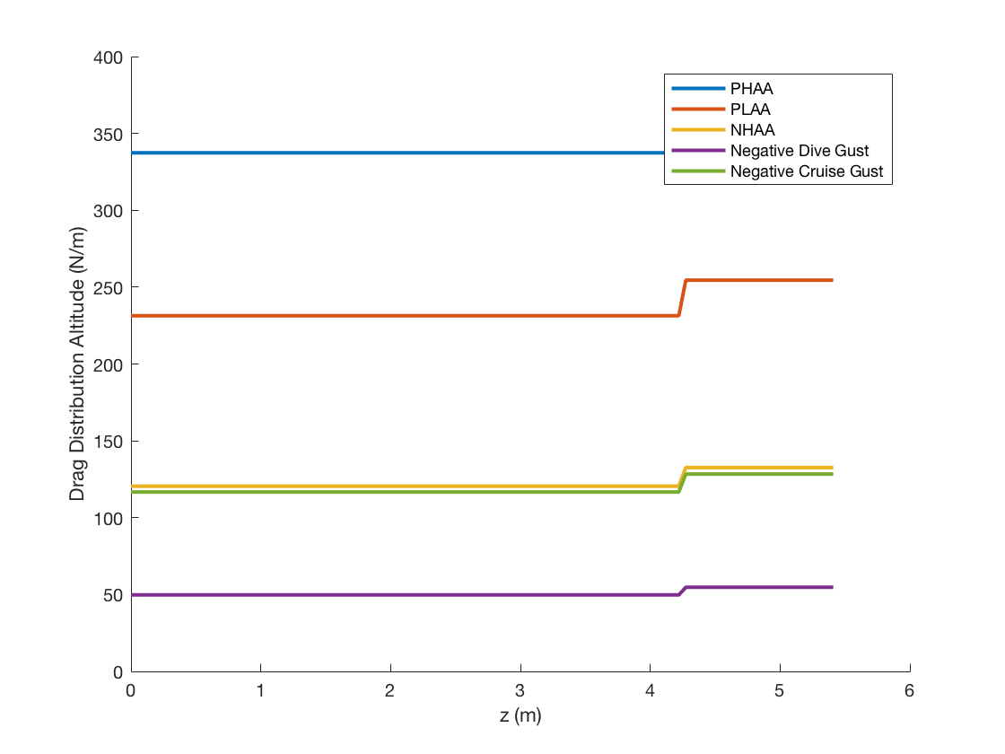

Figure : Drag Distribution (Altitude)

As shown in the figure above, the drag reaches a maximum at the last 20% of the span, due to the increased drag from vortex shedding, with a magnitude just below 4500 N/m. With the distribution of lift and drag known, their components were rotated to match the coordinate axes of the plane in order to get normal and parallel distributions along the wing.

### 3.1.3) Total Load Distribution on Wing

In order to determine the loads normal and parallel to the wing, the components of lift and drag were accounted for in these directions. Figure 15 below shows the coordinate axes used for this transformation.

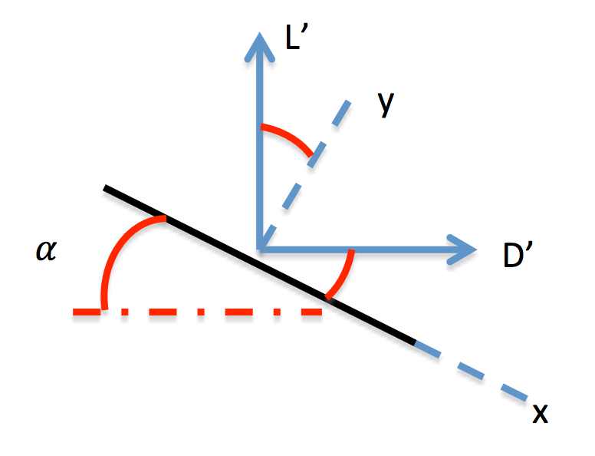

Figure : Coordinate Axes for Transformation

The positive y-axis is defined to be normal (upward) to the wing surface, while the positive x-axis is toward the trailing edge. The z-axis (not shown) is in the spanwise direction through the left wing. Equation 19 and Equation 20 show the transformations used.

*(Equation 19)*

*(Equation 20)*

where α is the angle of attack, L’ is the lift distribution, and D’ is the drag distribution. Figure 16 and Figure 17 show the load distributions on the wing at sea level and altitude.

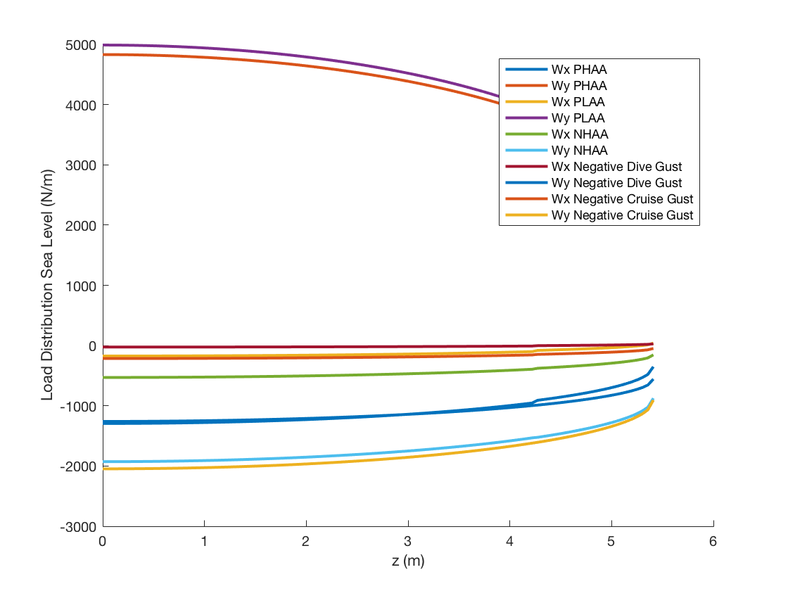

Figure : Wing Load Distribution (Sea Level)

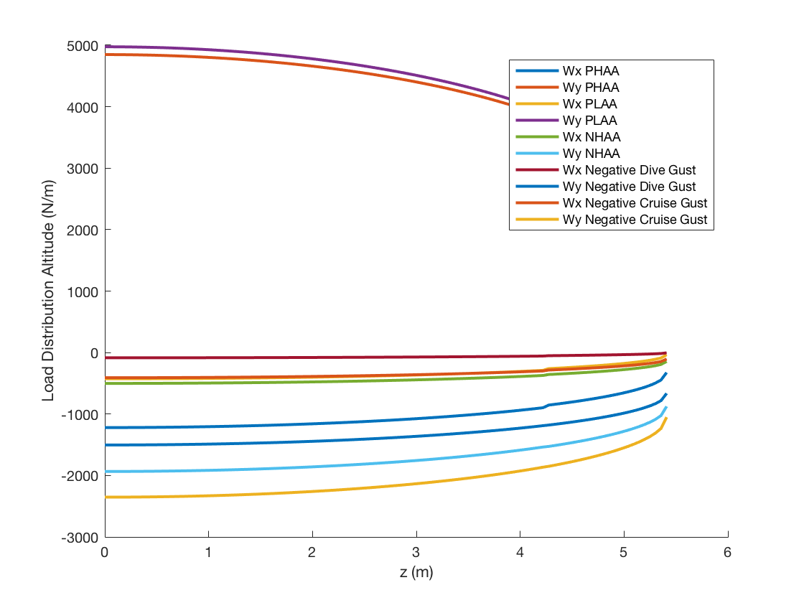

Figure : Wing Load Distribution (Altitude)

Examining the figures above, the highest load distribution in x is at the xx critical point, with a magnitude of ~xx N/m. The highest load distribution in y is at the xx critical point, with a magnitude of ~xx N/m. The trends for the xx, xx critical points have a similar shape, but the xx critical point is opposite in sign. Next, the geometry of the wing was considered, which is needed for the calculations of bending, shear, stress, and wing deflection.

## 3.2) Wing Structure

The wing structure is broken down into several different components. First, the geometry of the wing will be discussed, which will be essential in determining the centroid and area moment of inertia for the wing.

### 3.2.1) Geometry (Cantilever beam model)

Rather than use the actual geometry of the NACA 2415, a simplified model was first used. Cross sections were assumed to be uniform from root to tip, instead of transitioning from a NACA 2415 to a NACA 2412 airfoil. The airfoil was broken into quadrilateral sections, with the leading edge being rectangular and the trailing edge slanted at 30°. Included in the airfoil geometry were eight L brackets, four skin panels, and three spars. The dimensions of these pieces were initially sized with the values shown in Table 11 below.

|  |  |
| --- | --- |
| Chord [m] | 1.5 |
| Skin Thickness [m] | 0.001016 |
| Spar Height [m] | 0.08 |
| Spar Thickness [m] | 0.0025 |
| Bracket Height [m] | 0.015 |
| Bracket Thickness [m] | 0.0025 |
| Slant Angle [°] | 30 |

Table : Structural Component Sizing

A drawing of the approximate shape of the wing is shown in Figure 18 below. The skin panels are shown in blue, the spars in green, and the brackets in black.

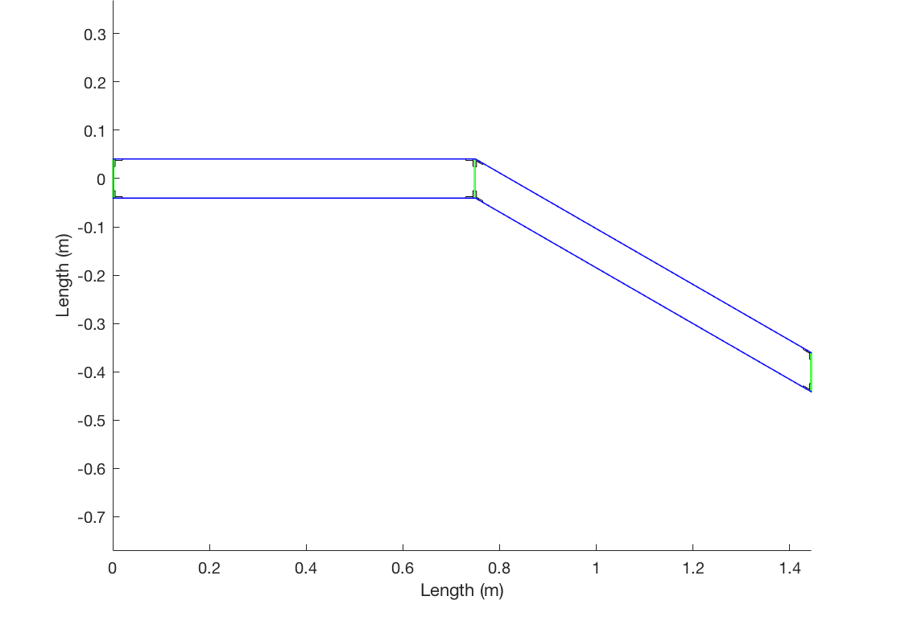

Figure : Approximate Wing Geometry

With an approximate shape for the wing, further calculations were made in order to determine the centroid.

### 3.2.2) Centroid

In order to find the overall centroid of the wing, the centroid of each internal structure was found first. As mentioned, each shape was approximated as a quadrilateral. Equation 21 and Equation 22 were used to find the x and y centroid location for each piece.

*(Equation 21)*

*(Equation 22)*

where xi and yi are the x and y coordinates for the corners of each shape, following the convention shown in Figure 19.

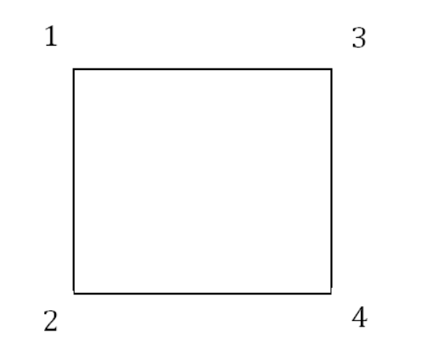

Figure : Point Numbering Convention

The area of each component was also calculated by using Equation 21.

*(Equation 21)*

With the centroid of each part and the respective area, the total centroid was calculated with Equation 22 and Equation 23.

*(Equation 22)*

*(Equation 23)*

The sketch of the airfoil with the location of the centroid is shown in Figure 20 below, with the coordinates given by Table 12.

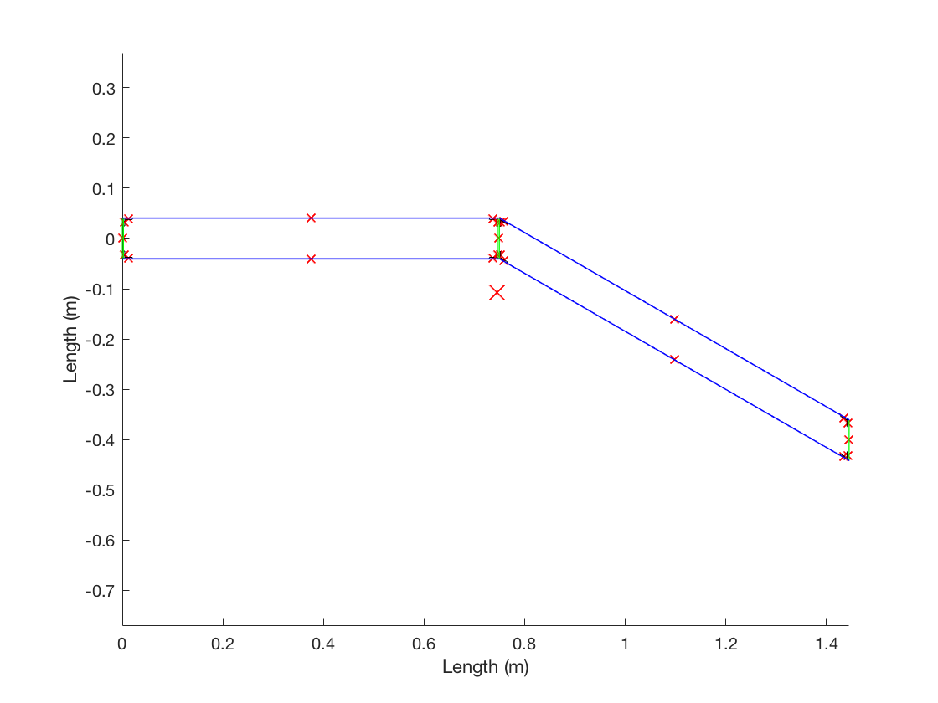

Figure : Approximate Wing Geometry with Centroid Locations

|  |  |
| --- | --- |
| Cx [m] | 0.7445 |
| Cy [m] | -0.1074 |

Table : Centroid Coordinates

As seen from the figure and table above, the centroid location is (0.7445, -0.1074) [m], which is shown by the large X marker. With the centroid known, the next step was to calculate the area moment of inertia.

### 3.2.3) Area Moment of Inertia

A method of components was used to calculate the total area moment of inertia. First, the inertia of the various components was calculated about its local centroid. Next the parallel axis theorem was applied in order to find the area moment of inertia about the structure’s total centroid.

The following equations were used to calculate the area moment of equations for the straight non tilted sections in the leading edge:

*(Equation 24)*

*(Equation 25)*

*(Equation 25)*

It is important to note that the product of inertia of the various straight pieces would be zero due to symmetry, therefore only the parallel axis term was considered as shown in Equation 25.

At the trailing edge of the airfoil, all the components were tilted by a specified angle. The following equations were used to calculate the area moment of inertia accounting for this rotation at the trailing edge portion of the airfoil:

*(Equation 26)*

*(Equation 27)*

*(Equation 28)*

In the equations above *a* is taken to be the length component that is most perpendicular to the axis in question while *t* is taken to be the length component that is most parallel. The angle *β*, is taken as the negative of the rotation angle. As shown by Equation 28, because of the asymmetric nature of these tilted components the product of inertia is no longer zero.

After the area moment of inertias were calculated for the various components a sum was taken, in order to find the area moment of inertia of the entire structure.

|  |  |  |
| --- | --- | --- |
| **Ixx [10-4 m4]** | **Iyy [10-4 m4]** | **Ixy [10-4 m4]** |
| 1.5940 | 2.8739 | -1.9141 |

Table : Total Area Moment of Inertia

## 3.3) Structural Loads

Various loads were considered and analyzed throughout the allowable flight envelope. First, shear and bending moments were derived from the span-wise load distribution. Then, the wing stress and wing deflection were calculated using the material and geometry properties of the wing. All calculations were repeated at each of the five critical points at both sea level and altitude.

### 3.3.1) Shear

Shear forces in the defined x and y directions, are caused by a combination of lift and drag forces on the wing. The load distributions wx and wy were integrated over the semi span to get total shearing force in both directions along the span as shown in Equation 29. A trapezoidal numerical approximation was used for this integral.

*(Equation 29)*

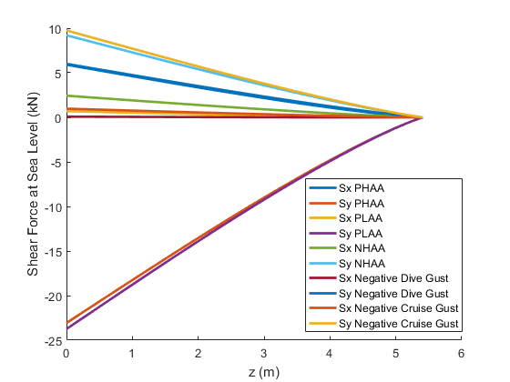

Figure : Shear Force Along Span (Sea Level)

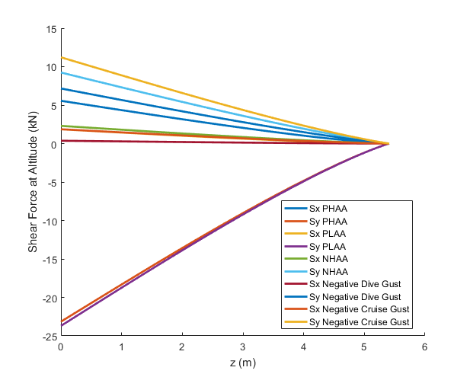

Figure : Shear Force Along Span (Altitude)

The shear forces for both x and y converge to zero at the tip just as the load distributions do. The shear force accumulates tip to root and is therefore maximum at the root.

### 3.3.2) Bending Moments

Next, from the previously derived shear force, the moments Mx and My were calculated. This is done by integrating the shear force along the semi span of the wing.

*(Equation 30)*

For this integration a trapezoidal numerical approximation was used. Generally, the bending moment Mx would be due to the lift force and My due to the drag force for low angles of attack. For higher angles of attack both lift and drag contribute to moments Mx and My. The results of each analysis are given in the figures below. 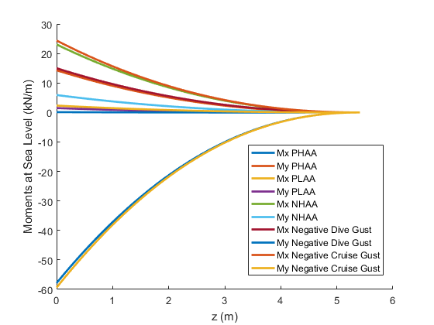

Figure : Bending Moments (Sea Level)

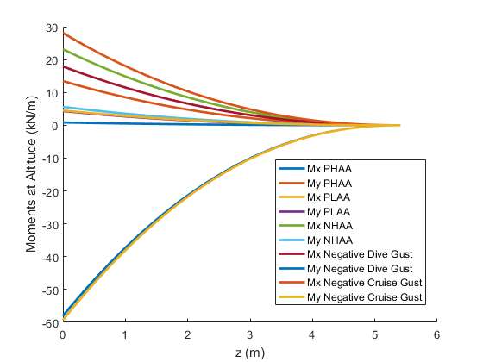

Figure : Bending Moments (Altitude)

Note that the bending moments all converge to zero at the tip of wing. This is reasonable given the model used. In some cases, the moment curves of two different critical points are almost exactly coincident and therefore may be difficult to see on the graph.

### 3.3.3) Wing Tip Deflection

The various bending loads causes the wing tips to move from their original non-loaded positions. It is important to analyze this displacement to ensure that the wings are deforming within a reasonable and safe range.

The displacement was calculated along the semi-span using the following equations:

*(Equation 31)*

*(Equation 32)*

Equations 31 and 32 were integrated twice in order to find the corresponding displacements. The results for both sea level and altitude are shown in the following figures.

*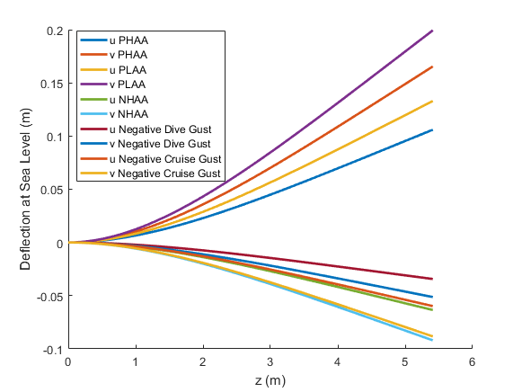*

Figure : Wing Displacement (Sea Level)

*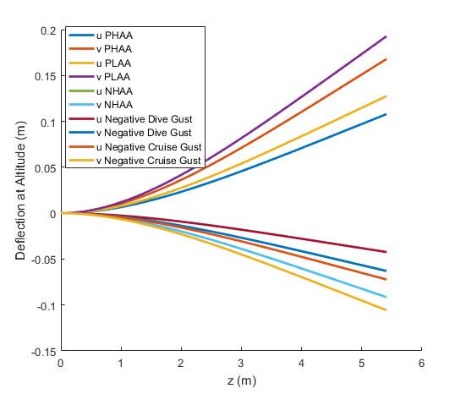*

Figure : Wing Displacement (Altitude)

Notice that the displacement is zero at the root of the wing structure and maximum at the tips, this was expected since the root acts as a clamped section of a cantilever beam. It is also important to note that the largest deflections are along the y direction. Given the geometry of the structure it should bend much easier along the y than along the x direction.

### 3.3.4) Stress

For this analysis only bending stresses were considered, specifically σzz. Bending stresses are induced by the bending loads Mx and My introduced above and take into account the cross sectional geometry of the section. The following equation was used to calculate the bending stress.

*(Equation 33)*

In Equation 33 the stress can be calculated at any cross sectional point. For this analysis the stress was found along the centroid of the wing cross section. The stress analysis results are given in the figures below.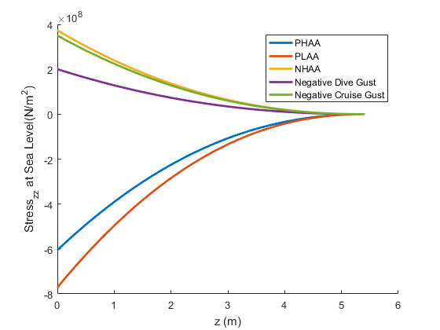

Figure : Wing Stress (Sea Level)

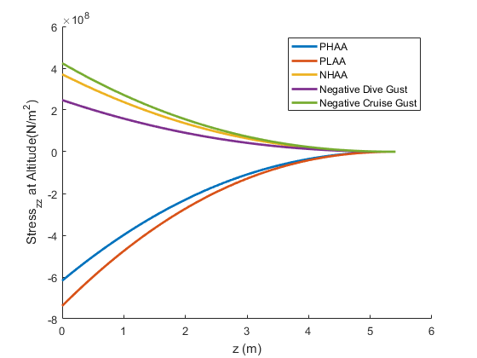

Figure : Wing Stress (Altitude)

Note again that the stress in Figures 28 and 29 converges to zero at the tip. This is because the bending moments also converge to zero at the tips as shown by Figures 23 and 24. Due to the uniform airfoil of this wing, the maximum span-wise location of stress also corresponds to the maximum location of bending moment, the root.

# 4) Conclusion and Future Analysis

This simplified analysis of a cambered wing airfoil was used to prove that such analysis is feasible using various tools such as xFoil, MatLab, and Excel. With a few assumptions and guided by the FAR 23, analysis of various loading conditions was completed. These loading conditions included shear loads, bending moments, stress and wing deflection calculations at the several critical points associated with the flight envelopes at both sea level and at altitude.

Subsequent analyses will not include as many simplifying assumptions and will provide a more in depth and ultimately more accurate approximation of loads at various flight conditions. From these more accurate models optimization will be performed in order to converge on the lightest structural design while maintaining airworthiness.

# 5) References

Megson, T. H.G. *Aircraft Structures for Engineering Students*. Oxford: Elsevier Science & Technology, 2012. Print.

Lynch, C.S. *Design Of Aerospace Structures: Week 2 Lecture 2B*. 1st ed. 2016. Print.